Home

**CMC Limited**

SIX WEEKS INDUSTRIAL TRAINING REPORT

on

**E-MANDI**

**Bachelor of Technology**

**In**

**Computer Science**

**Submitted To Submitted By**

**Mr. Pawan Sharma Abhiskek Kumar Singh**

ACKNOWLEDGMENT

Apart from the efforts of me, the success of my project depends largely on the encouragement and guidelines of many others. I take this opportunity to express my gratitude to the people who have been instrumental in the successful completion of this project.

I would like to show my greatest appreciation to my project in-charge, MR Pawan Sharma. I can’t say thank you enough for the tremendous support and help. I feel motivated and encouraged every time I attend her meeting. Without her encouragement and guidance this project work would not have materialized.

I’m highly grateful to him, for his thorough guidance right from day 1 till the end of training. He actually laid the ground for conceptual understanding of technologies used in project.

(Abhishek Kumar Singh)

**TABLE OF CONTENTS**

**1. INTRODUCTION**

1.1 Purpose…………………………………………………………………………………………………………..3

1.2 Scope………………………………………………………………………………………………………………3

1.3 Definitions, acronyms and abbreviations………………………………………………………..4

1.4 Tools used………………………………………………………………………………………………………6

1.5 References……………………………………………………………………………………………………..8

1.6 Technologies to be used…………………………………………………………………………………8

1.7 Overview………………………………………………………………………………………………………..7

**2. OVERALL DESCRIPTION**

2.1 Product Perspective……………………………………………………………………………………….10

2.2 Software Interface………………………………………………………………………………………….10

2.3 Hardware Interface ……………………………………………………………………………………….11

2.4 Communication interface………………………………………………………………………………12

2.5 Constraints ……………………………………………………………………………………………………12

2.6 E-R diagram…………………………………………………………………………………………………..12

2.7 Use case model survey………………………………………………………………………………….14

2.8 Architecture diagram…………………………………………………………………………………….17

2.9 Schema…………………………………………………………………………………………………………18

**3. SPECIFIC REQUIREMENTS**

3.1 Use Case Reports………………………………………………………………………………………….19

3.2 Activity diagrams……………………………………………………………………………………………30abhishek221192

**1. INTRODUCTION**

**1.1 PURPOSE**

It is an **electronic vegetable market** making the vegetable market more convenient for the use of civilian and even to keep the **transparency in the whole market system** from retailer to the whole seller.

**The main objective of this project is**

* To build a website which will help civilian, retailer, whole seller and even the framer to get the best from his inputs.
* With the help of this a farmer will be able to know the best value for his vegetable and will not be fooled by the marketers.
* It will help in keeping **the transparency between the wholesalers and retailer** and also the selection for civilian for his requirement become easy .
* This will help in eradicating **black marketing and inflation.**
* It aims to **help the farmers**, to help them **know about their rights and policies of the** **government** and get latest information about their crop.

**1.2 SCOPE**

* There are six basic users - **Farmers, Admin, Wholesalers, Retailers , Employees and customers.**
* All users have their own profiles in **E-MANDI**.
* **The live group chats** between wholesalers, retailers and farmers, member.
* People can register to have a complete view of the market including the pricing of vegetables, pricing difference between whole seller and retailer, actual pricing stated by government, best possible retailer in the market for civilian in his area, revenue generated last month and a period of time
* Non registered can have an overview of these facilities excluding some.
* **Feedback or complaint facilities** directly connected to government bodies to keep a view on the market but mentioning the unique id of the complainer
* Admin should be able to see all record from any users.
* The records shown for selling should be available in a format of Quantity name , Quantity available, price.
* The database should be robust enough to handle all the online transactions which will be happening.
* People will have facility of viewing the price difference between **different regions and the inflation rate also.**
* Help section for those who are unable to understand the website or any of its part
* **Admin** has the authority to add/delete users**, grant permission to members and to generate** **and view reports**. He also views the complaints of farmers, retailers and wholesalers and takes necessary actions.
* It also provides **SMS services** to the farmers on their phones as they don’t have easy access to the internet facilities. Such messages provide them **information about crop rates, wholesalers and retailers of their regions.**

**1.3 DEFINITIONS,ACRONYMS AND ABBREVIATIONS**

**E-mandi**

**Electronic mandi**

**Admin**

**Administrator** . He has the authority to add/delete users, grant permission to members and to generate and view reports.

**Apache Tomcat Server**

It is an open source web server and servlet container developed by the Apache Software Foundation(ASF). Tomcat implements the Java Servlet and the Java Server Pages (JSP) specifications from Sun Microsystems, and provides a "pure Java" HTTP web server environment for Java code to run.

**Oracle 10g**

A database management system that provides a flexible and efficient database platform to maintain records of members, farmers, wholesalers and retailers.

**JSF**

**Java Server faces.** JSF is a rich featured framework of JAVA technology. JSF provides a set of standard features that makes it a powerful and standard among the existing technologies available for the development of web application based on java technologies. Some of the features have been given

below to justify the above statement.

* JSF is standard web user interface framework for Java.
* Built on top of Servlet API.
* JSF is a component framework
* UI components are stored on the server.
* Easy use of third party components.
* Event driven programming model.
* Events generated by user are handled on the server.
* Navigation handling.
* Can automatically synchronize UI components .
* JSF supports multiple client devices.
* JSF has extensible architecture.
* International language support.
* Extensive tool support (Sun, Oracle , IBM etc.).
* Rapid application development approach. used to manage all jsf page content and help in interaction with database
* Intensive AJAX implementation.

**JDBC**

**Java Database Connectivity**. **JDBC** is a Java-based data access technology (Java Standard Edition platform) from Oracle Corporation. This technology is an API for the Java programming language that defines how a client may access a database. It provides methods for querying and updating data in a database. JDBC is oriented towards relational databases. A JDBC-to-ODBC bridge enables connections to any ODBC-accessible data source in the JVM host environment.

**J2EE**

**Java 2 Enterprise Edition.** A programming platform which is a part of java platform for developing and running distributed java.

**UML**

**Unified Modeling Language** is a standard language for writing software blueprints. The UML may be used to visualize, specify, construct and document.

**XML**

**Extensible Markup Language** is a text based format that let developers describe, deliver and exchange structured data between a range of applications to client for display and manipulation.

**HTTP**

**Hypertext Transfer Protocol.** It’s a service protocol.

**1.4 TOOLS USED**

**Application architecture – JAVA, J2EE**

**JAVA**

Java is an object-oriented programming language developed by **Oracle** . Java language was designed to be small, simple, and portable across platforms, operating systems, both at the source and at the binary level, which means that Java programs (applet and application) can run on any machine that has the Java virtual machine (JVM) installed.

**J2EE**

**Java Platform, Enterprise Edition** or **Java EE** is a widely used platform for server programming in the java programming language. The java platform (Enterprise Edition) differs from the java standard edition platform (Java SE) in that it adds libraries which provide functionality to deploy fault-tolerant, distributed, multitier, Java software, based largely on modular components running on an application server.

**APACHE TOMCAT SERVER**

It is an open source web server and servlet container developed by the Apache Software Foundation(ASF). Tomcat implements the Java Servlet and the Java Server Pages (JSP) specifications from Sun Microsystems, and provides a "pure Java" HTTP web server environment for Java code to run.

**DATABASE PLATFORM-Oracle10g**

**Oracle10g** Database is the database management system that delivers a flexible and cost effective database platform to build robust on demand business applications and supports the J2EE and web services standards.

**Sencha Extjs**

Sencha Space is a secure, cross-platform environment for your HTML5 apps. You can use it to help:

* **Build** — Reduce the cost of developing secure, cross-platform mobile apps
* **Deploy** — Simplify app deployment for both testing and production
* **Manage** — Enforce policies to secure your users, data, and applications

**Ext JS** is a pure JavaScript application framework for building interactive web applicationsusing techniques such as Ajax, DHTML and DOM scripting.

Originally built as an add-on library extension of YUI by Jack Slocum, Ext JS includes interoperability with jQuery and Prototype. Beginning with version 1.1, Ext JS retains no dependencies on external libraries, instead making their use optional.

### GUI controls

Ext JS includes a set of GUI-based form controls (or "widgets") for use within web applications:

* text field and text area input controls
* date fields with a pop-up date-picker
* numeric fields
* list box and combo boxes
* radio and checkbox controls
* html editor control
* grid control (with both read-only and edit modes, sortable data, lockable and draggable columns, and a variety of other features)
* tree control
* tab panels
* toolbars
* desktop application-style menus
* region panels to allow a form to be divided into multiple sub-sections
* sliders
* vector graphics charts

**1.6 TECHNOLOGIES TO BE USED**

* + Oracle10g: Relational Database Management System
  + Eclipse Juno.
  + Apache tomcat server
  + JSF:Java Server Faces
  + JDBC: java database connectivity
  + Sencha Extjs

**1.7 OVERVIEW**

**Existing system**

* Registration for users
* Discussion forums

**Drawbacks**

* No facility for live chats
* Farmers don’t know about their rights and policies of the government

**Proposed system**

* **Live chat.**
* Registration for users, farmers, wholesalers, retailers
* Employees to manage the interaction between different users and generate reports to the admin.

**Our plan**

* Registration for users
* **Live chat**.
* Feedback or complaint facilities directly connected to government bodies to keep a view on the market but mentioning the unique id of the complainer
* Person have facility of booking vegetables for commercial use on a large scale online through bigger marketers
* **Help section** for those who are unable to understand the website or any of its part
* All Price will be shown in **regional language** by using **JAVA Locale class**
* Wholeselar and retailer will be register only after giving their identity and address proof.
* Only customer and farmer will be register directly after supplying their details.
* It also provides **SMS services** to the farmers on their phones as they don’t have easy access to the internet facilities. Such messages provide them **information about crop rates, wholesalers and retailers of their regions.**

**2. OVERALL DESCRIPTION**

**2.1 PRODUCT PERSPECTIVE**

**WEBSPHERE SOFTWARE**

**APPLICATION SERVER**

**INFORMATION MANAGEMENT**

**SOFTWARE**

BROWSER

WEB SERVICES CLIENT

HTTP SERVER

**DB2**

**JAVA BEANS**

WEB SERVICES ENGINE

MESSAGING ENGINE

EJB’S

|  |
| --- |
| **Product** |
| product_id(pk) |
| name |
| category |
| season |
| gov_price |
| whole_price |
| retailer_price |
| stock_capacity |
| capacity_used |
| tot_capacity |
| rating |
| review_id(fk) |
| farmer_id(fk) |
| image_id |

**WEB CONTAINER**

JSF and managed beans

|  |
| --- |
| **Product** |
| product_id(pk) |
| name |
| category |
| season |
| gov_price |
| whole_price |
| retailer_price |
| stock_capacity |
| capacity_used |
| tot_capacity |
| rating |
| review_id(fk) |
| farmer_id(fk) |
| image_id |

**PRODUCT PERSPECTIVE**

**2.2 SOFTWARE INTERFACE**

**Client on Internet**

Web Browser, Operating System (any)

**Web Server**

Apache tomcat server, Operating System (any)

**Data Base Server**

ORACLE10G, Operating System (any)

**Development End**

ORACLE10G, OS (Windows),apache tomcat server

**2.3 HARDWARE INTERFACE**

**Minimum Requirements**

|  |  |  |  |
| --- | --- | --- | --- |
|  | Client Side |  |  |
|  | **Processor** | **RAM** | **Disk Space** |
| Internet Explorer-8 | **Any processer** | **512MB** | **100MB** |

|  |  |  |  |
| --- | --- | --- | --- |
|  | Server Side |  |  |
|  | **Processor** | **RAM** | **Disk Space** |
| Tomcat Apache Server | **Any Processor** | **1 GB** | **3.5GB** |
| ORACLE10G |  | **1 GB** | **10GB** |

**Recommended Requirements:**

|  |  |  |  |
| --- | --- | --- | --- |
|  | Client Side |  |  |
|  | **Processor** | **RAM** | **Disk Space** |
| Web Browser with CSS3 Support | **Any processer** | **512MB** | **100MB** |

|  |  |  |  |
| --- | --- | --- | --- |
|  | Server Side |  |  |
|  | **Processor** | **RAM** | **Disk Space** |
| Websphere | **Any Processor** | **2 GB** | **3.5GB** |
| ORACLE10G |  | **2 GB** | **50 GB** |

**2.4 COMMUNICATION INTERFACE**

* Client (customer) on Internet will be using HTTP/HTTPS protocol.
* Client (system user) on Internet will be using HTTP/HTTPS protocol.
  1. **CONSTRAINTS**
* Login and password is used for the identification of users.
* Only registered farmers, wholesalers and retailers will be authorized to use the services.
* Customers will be provided limited privileges without registration.
* Limited to HTTP/HTTPS.
* Many problems relating to information security also prevails
  1. **E-R DIAGRAM**

Given below is the E-R diagram.

* The ellipse shown in **green represent** **primary key**.
* The ellipse shown in **purple represent** **foreign key.**
* The ellipse shown in **blue** represent other attributes.
* The square boxes shown in **red** represent **entities.**
* The rhombus shown in **red** represent **relations.**

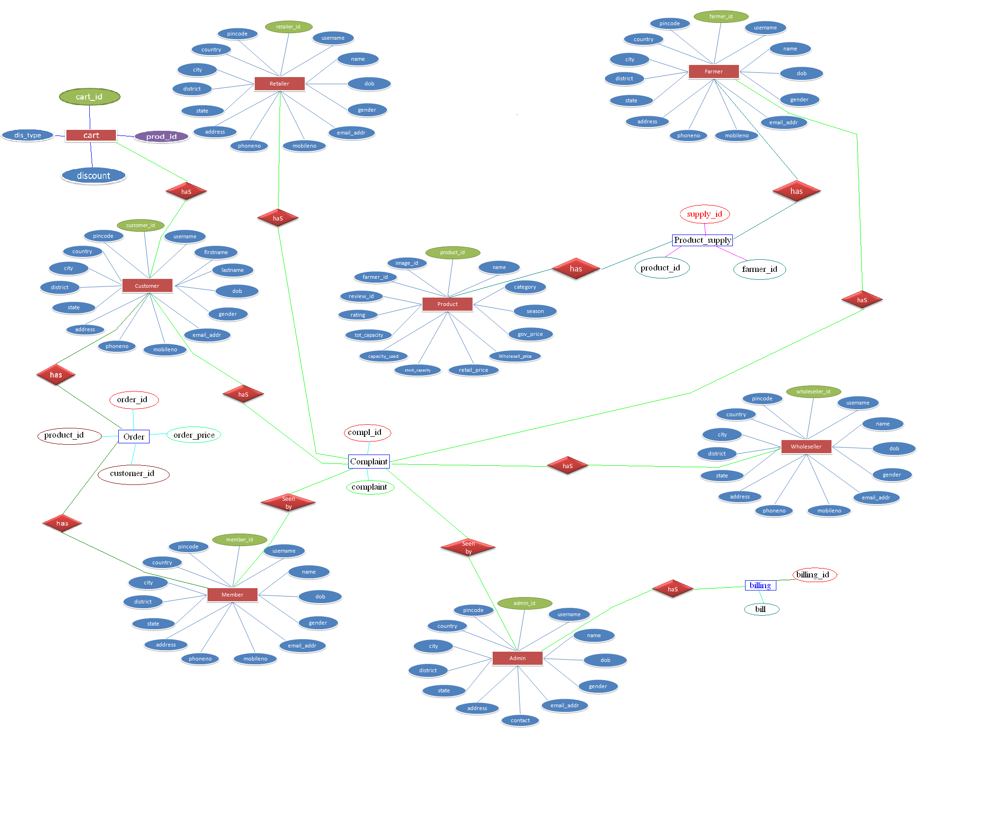

**2.7 USE CASE MODEL SURVEY**

**Farmer**

Farmer can register himself just by entering his detail and product list he is going to supply. He can view government price. He can even ask for any financial help by just submitting to E-mandi.



**Customer**

Customer can see E-mandi products.He can compare price between government price and e-mandi price.He can see all stage where price has been added or removed.He can buy product from E-mandi from any corner of world.



**Admin**

Admin has the authority to add/delete users. He can view progress report of emandi. Administrator is owner or controller of E-mandi .

He can view any details that may be farmer, customer, wholesaler, retailer, employee .All employee will be registered after his permission and he can select their respective task means do and don’t of employee will be selected by only admin.



**Employee**

Employee will be under admin. Registration of wholesaler and retailer will be handled by him. He can add or update product details. Farmer complaints will be manage by him.



**Wholesaler**

Wholesaler have to submit his identity and address proof at time of registration. He can view farmer list and their products. He can even buy products from E-mandi which is out of his reach.



**Retailer**

Retailer have to submit his identity and address proof at time of registration. He can view wholesaler list and their products. He can even buy products from emandi which is out of his reach.

**2.8 ARCHITECTURE DIAGRAM**

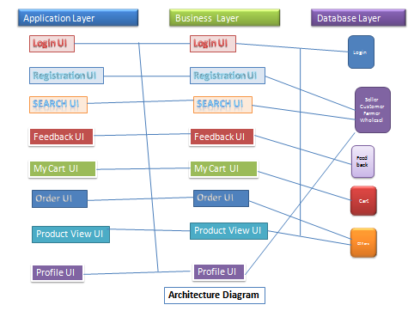

**2.9 SCHEMA**

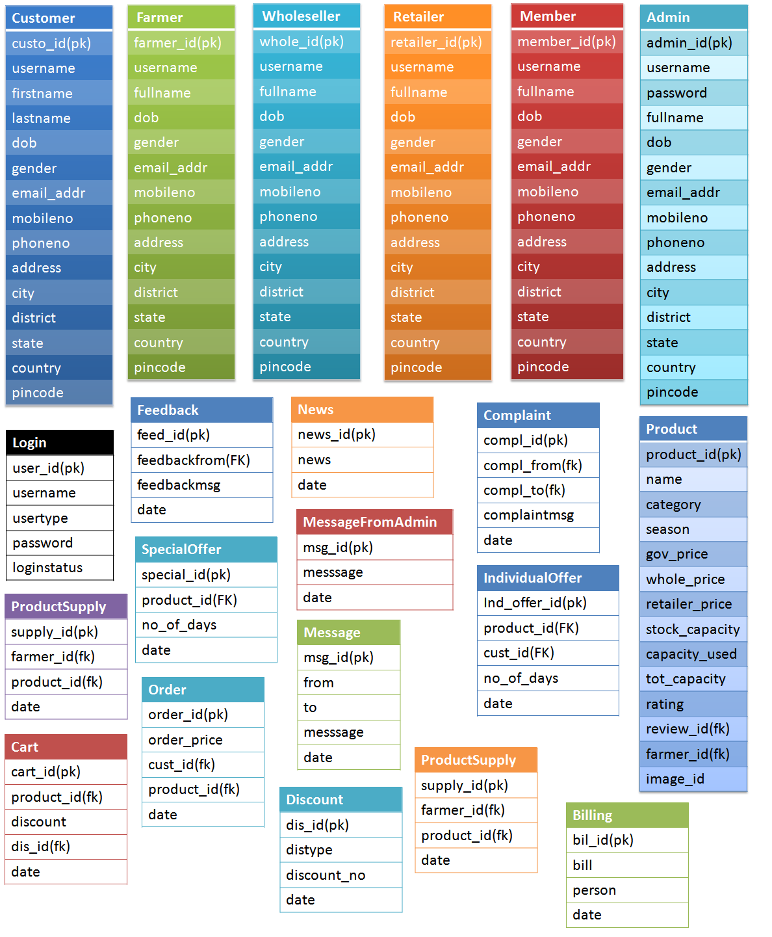

**3. SPECIFIC REQUIREMENTS**

**3.1 USE CASE REPORTS**

**3.1.1** RETAILER USE CASE REPORT



**RETAILER**

|  |  |
| --- | --- |
| USE CASE | DESCRIPTION |
| Register | to create an account |
| Login | to enter into one’s account and get access to the facilities. |
| View product | To view the products i.e their price and information |
| View and edit profile | To view and modify the contents of one’s account whenever needed |
| Farmer rate | Rate set by the government |
| Wholesaler rate | Rate at which product is provided by the farmer |
| Wholesaler details | Provides datails of the wholesaler |

**3.1.2** WHOLESELAR USE CASE REPORT



**WHOLESELLER**

|  |  |
| --- | --- |
| USE CASE | DESCRIPTION |
| Register | to create an account |
| Login | to enter into one’s account and get access to the facilities. |
| View product | To view the products i.e. their price and information |
| View and edit profile | To view and modify the contents of one’s account whenever needed |
| Farmer rate | Rate set by the government |
| Farmer details | Provides details of the farmer |

**3.1.3** CUSTOMER USE CASE REPORT



**CUSTOMER**

|  |  |
| --- | --- |
| USE CASE | DESCRIPTION |
| Register | to create an account |
| Login | to enter into one’s account and get access to the facilities. |
| View product | To view the products i.e. their price and information |
| View and edit profile | To view and modify the contents of one’s account whenever needed |
| See price | Rate set by the retailers |
| Feedback | Facility to provide feedback about the website and the facilities provided |
| Newsletter | Provided by the website to its users and provide useful information |
| Enter into public chat | Chat with the employees of e-mandi to get useful information. |

**3.1.4** FARMER USE CASE REPORT



**FARMER**

|  |  |
| --- | --- |
| USE CASE | DESCRIPTION |
| Register | to create an account |
| Login | to enter into one’s account and get access to the facilities. |
| View product | To view the products i.e. their price and information |
| View and edit profile | To view and modify the contents of one’s account whenever needed |
| See price | Rate set by the government |
| Feedback | Facility to provide feedback about the website and the facilities provided |
| Newsletter | Provided by the website to its users and provide useful information |
| Enter into public chat | Chat with the employees of e-mandi to get useful information. |
| Know about his crop | A farmer can know any information about his crop. |
| Know about his rights | A farmer can know about the rights and policies set by the government. |

**3.1.5** EMPLOYEE USE CASE REPORT



**ADMIN**



**EMPLOYEE**

|  |  |
| --- | --- |
| USE CASE | DESCRIPTION |
| Register | to create an account |
| Login | to enter into one’s account and get access to the facilities. |
| Generate and send reports | To generate reports to the admin about the activities of different users |
| View and edit profile | To view and modify the contents of one’s account whenever needed |
| Send emails and sms | To send emails to various users about their queries and to send sms to the farmers. |
| Configure and make changes | To update the data and facilities in the website as per the changing requirements from time to time. |
| Product detail | Employee can add new product or change price or update existing information. |
| Authenticate users | To authenticate wholesalers ,retailers and customers when they register. |

**3.1.6** ADMIN USE CASE REPORT



**ADMIN**

|  |  |
| --- | --- |
| USE CASE | DESCRIPTION |
| Register | to create an account |
| Login | to enter into one’s account and get access to the facilities. |
| Generate and receive reports | To generate reports t about the activities of different users and receive reports from employees |
| View and edit profile | To view and modify the contents of one’s account whenever needed |
| Send emails and sms | To send emails to various users about their queries and to send sms to the farmers. |
| View complaints and take action | To view complaints and feedback of various users and reply to their complaints. |
| Delete users | Admin can delete users when their registration expires. |
| Authenticate users | To authenticate various users whenever they register. |
| Take backup | Admin can take the backup of the website for security purpose. |
| View details of various users | Admin can view the details about any user whenever required. |

3.2 Activity Diagrams

Customer and farmer registration

Enter Details

Verification of Username

User already exists

Fill all mandatory field

Verification of password and mandatory fields

User Registration Successful

Go to homepage

Invalid

Valid

Invalid

Valid

Wholesaler and Retailer registration

Enter Details

Verification of Username

User already exists

Fill all mandatory field

Verification of password and mandatory fields

Set Prevleges

Go to homepage

Forward to Administrater for Approval

Administrator verification of Details

Approve Registration Successful

Deny Registration

Invalid

Invalid

Valid

Valid

Valid

Invalid

Customer and Farmer

Enter Username and Password

And Password

Verification of password and mandatory fields

User Login Successful

User homepage

Invalid

PrivilegedLogin

Enter Username and Password

And Password

Verification of password and mandatory fields

User Login Successful

User homepage

Set Admin Privileges

Set Wholesaler Privileges

Set Employee Privileges

Set Retailer Privileges

Invalid

Product Inquiry for Farmer

Enter a word to search Product

Select Product

View Government price

Find Wholesaler of his area(register to emandi)

Select Wholesaler

Set meeting

Live Chat

Enter your Query

Administrator is ready to chat

Administrator reply about query

Any other question user wants to ask

End the Chat

*yes*

*no*

Complaint

Enter Complaint text

Send to admin

Return Complaint ID

Generate Complaint ID

Reply to Complaint

View Complaint

Reply to User

Pass to government in case of any cheat to farmer of customer

BIBLIOGRAPHY

Adobe Dreamweaver CS5.5 .

Tomcat Apache Server

Oracle 10 g - Jeffrey R. Shapiro.

http://docs.oracle.com/javase/tutorial/

www.programmersheaven.com

csknwoledgehub.com

http://www.oracle.com/technetwork/java/javase/downloads/index.html